**2024.07.28**

**Engineering Question of PN:OCXO_DaughterCard**

**Question 1:**  The PCB board fabrication information is not specified.

**Suggestion:** Follow below information to make this board, unless otherwise specified.

Material: FR-4 TG≥130.

Finished board thickness shall be 1.6mm+/-10%.

Finished copper thickness shall be 35um on both outer layers and 35um base copper in inner layers.

Gloss green color of solder mask.

White color of silkscreen

Surface finish shall be HASL-lead free.

**Reply:** Matte black color of solder mask.

**Question 2:** See below IMG, the marked holes defined as PTH, but no annular rings.

**Suggestion:** Build them as Non-plated holes.

**Reply: Yes**

**PIC2:**

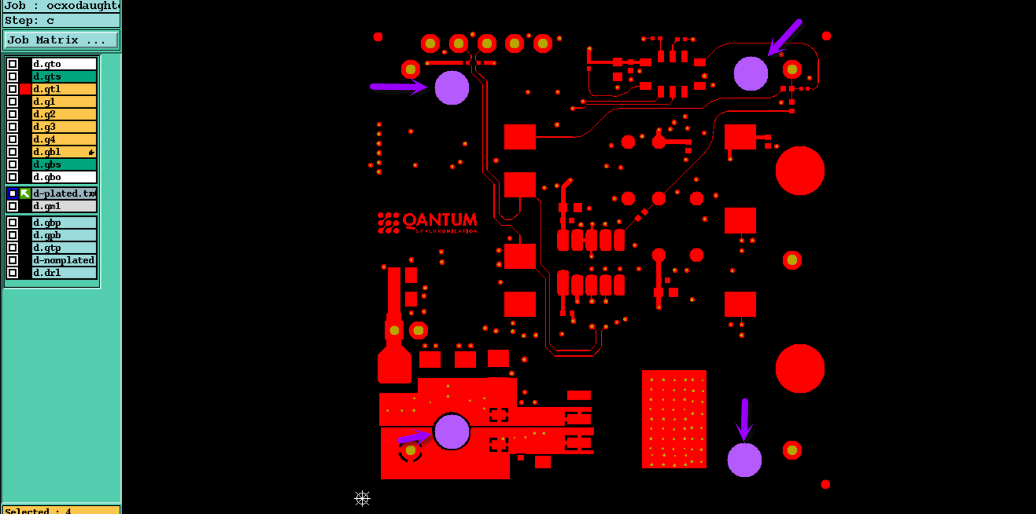

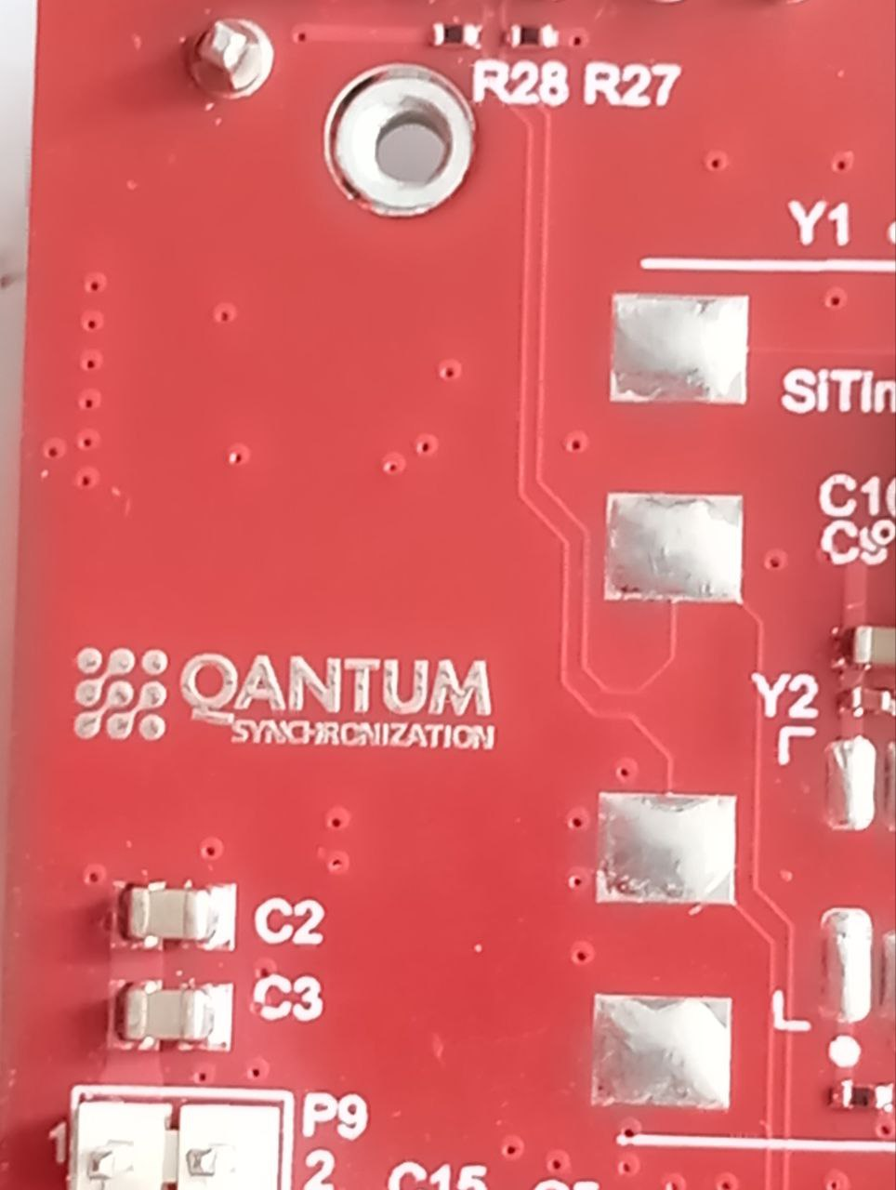

**Question 3:** See below IMG, the marked texts too small, we need enlarge them, and the texts will be fuzzy and unrecognized.

**Suggestion:** Accept those texts fuzzy and unrecognized.

**Reply: We will be satisfied with a fuzzy image**

**PIC3:**

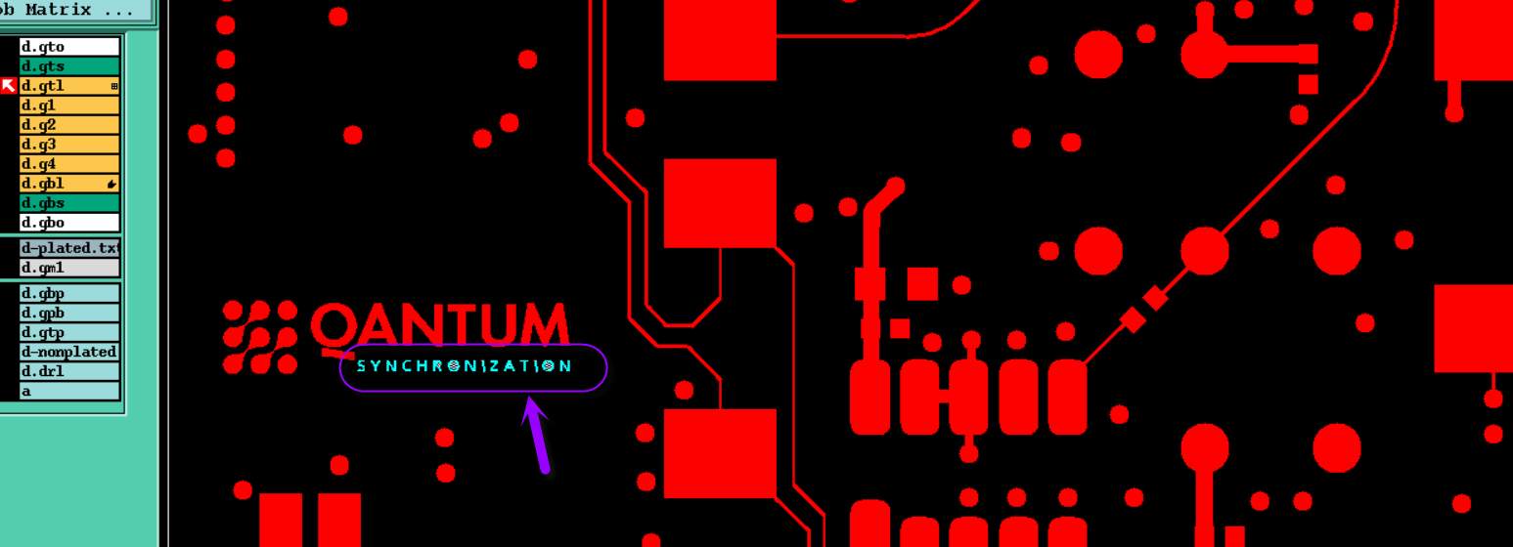



**Question 4:** See below IMG, there are two non-plated holes located on the Cu pad, we are not sure it is normal design or not.

**Suggestion 1:** Change them to PTH.

**Suggestion 2:** Make them as NPTH, but we need to cut the cu pad to get 0.2mm gap from holes edge to avoid copper exposed

**Reply: Both options will suit us. Which will be easier from a technological point of view. I attach a photo of the manufactured paragraph.**

**PIC4:**

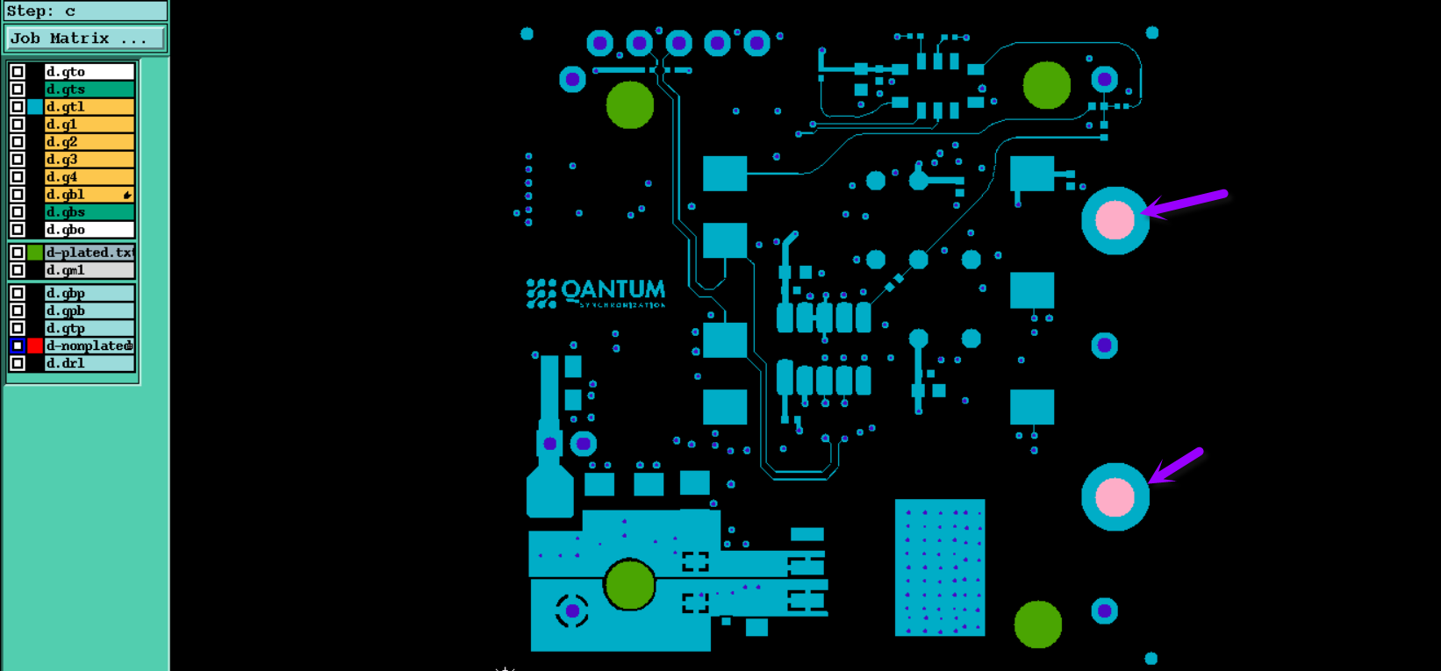

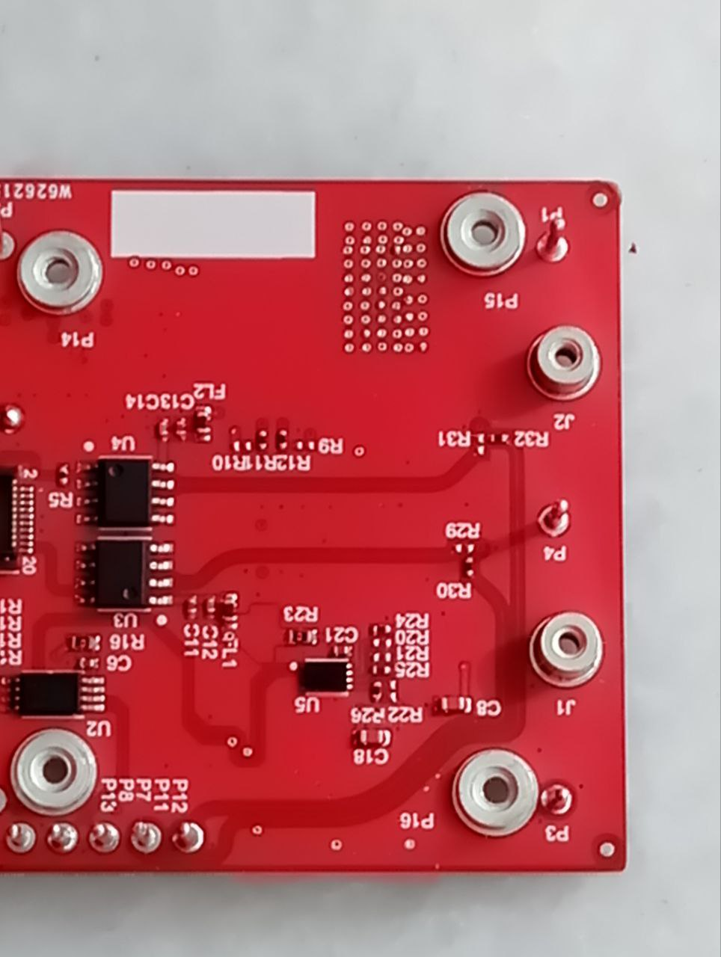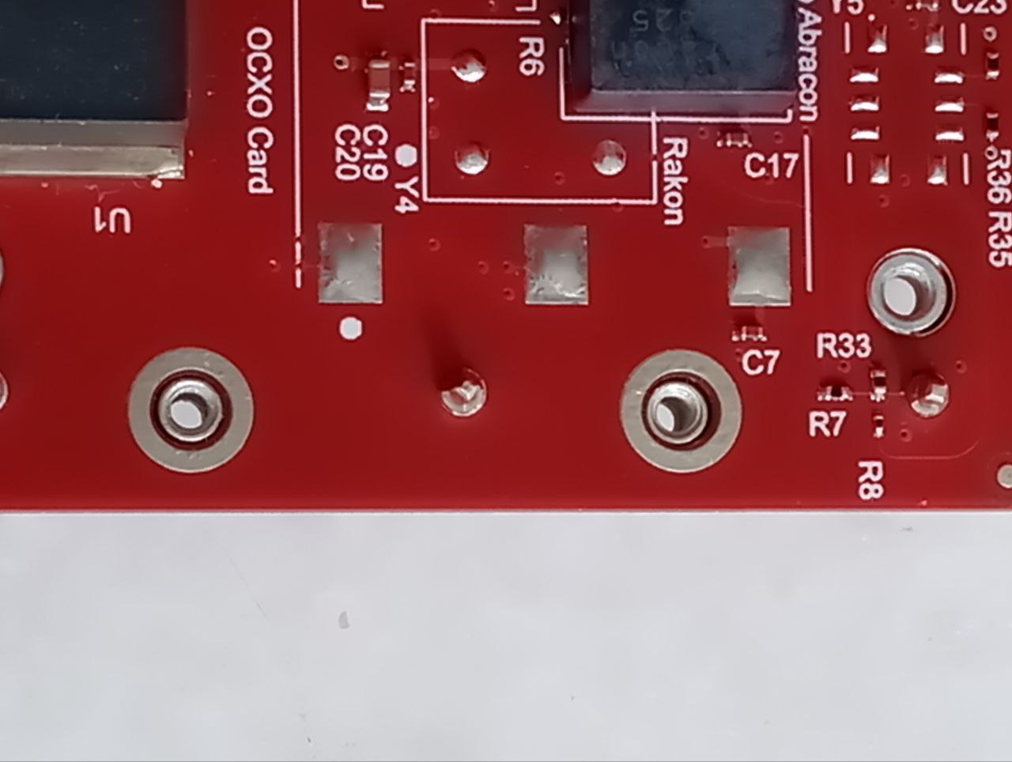

**Question 5:** See below IMG, there are designed with soldmask opening on some via holes. It will be easy cause shorten in solder process.Can we delete the soldmask opening of via holes and covered with soldmask ink？

**Suggestion 1:** Allow to delete the soldmask opening of all Dia0.3mm and covered with sodlamsk ink.

**Suggestion 2:** Follow the original gerber files.

**Reply: Suggestion 2**

**PIC5:**

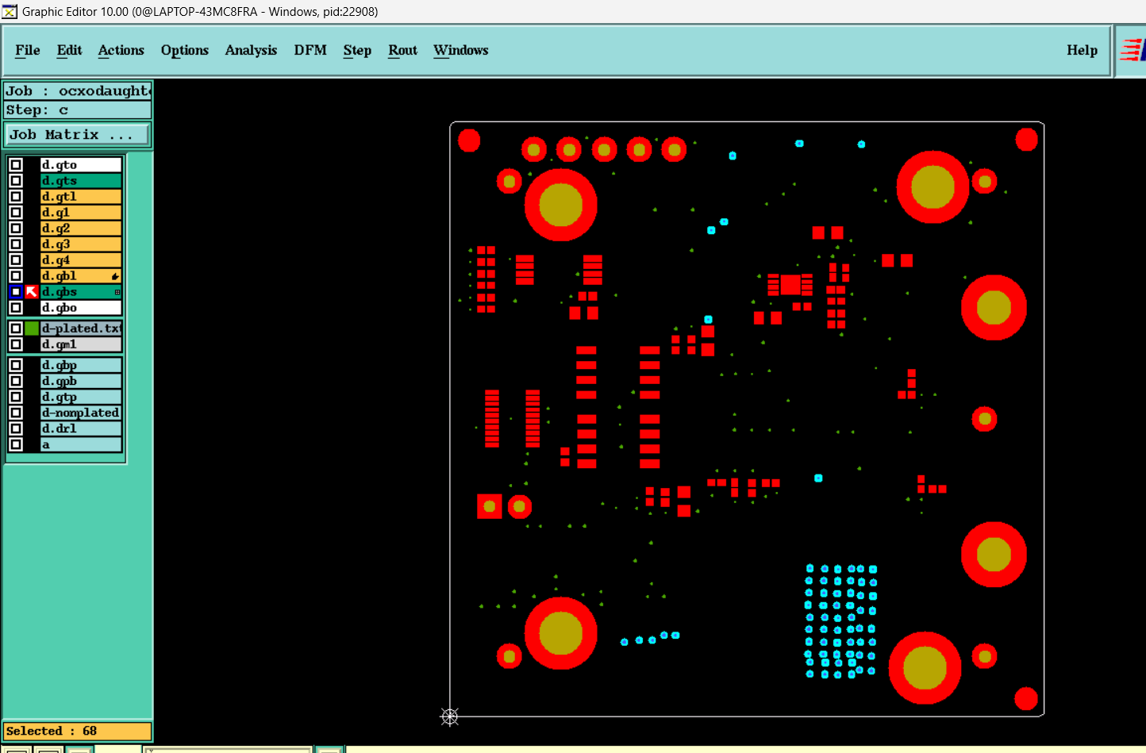

**Question 6:** See below IMG, to traceability, we will add datecode (wwyy) and silkscreen block(To laser engraving label (Include serial number info after assembly)) the top silkscreen layer, please confirm

**Suggestion:** Please confirm

**Reply: yes**

**PIC6:**

